ASSIGNMENT 4

Name: kandlagunta Lakshmi Mrudhula
Trainer name: Harshee Pitroda
Course name:Pyhton AI ML
Date: 02-06-2022

QUESTIONS

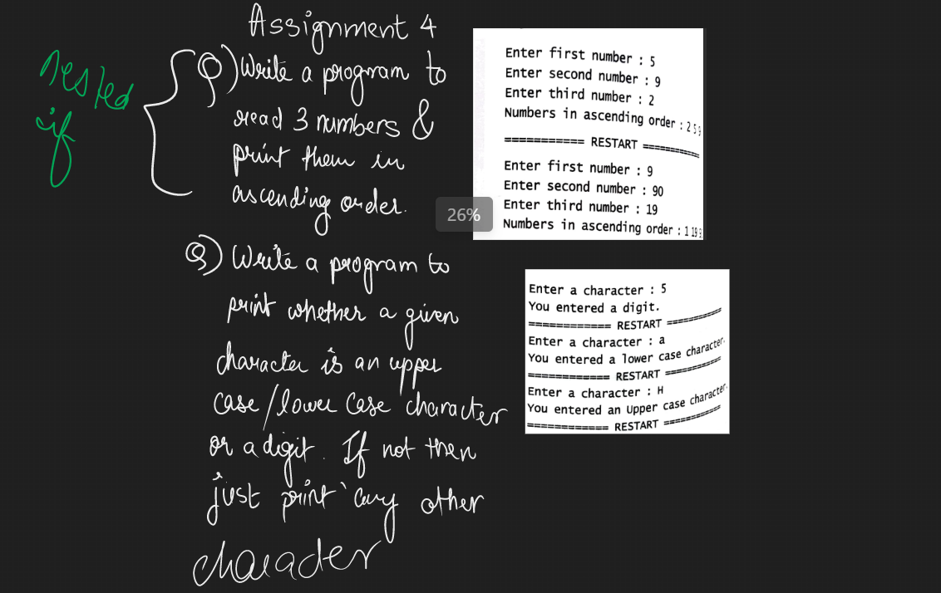

Q1:

code:

a=int(input("enter first number:"))
b=int(input("enter second number:"))
c=int(input("enter third number:"))
if a<b and a<c:
if b<c:
print("ascending order:",a,b,c)
else:
print("ascending order:",a,c,b)
elif b<a and b<c:
if a<c:
print("ascending order:",b,a,c)
else:
print("ascending order:",b,c,a)
else:
if a<b:
print("ascending order:",c,a,b)
else:
print("ascending order:",c,b,a)

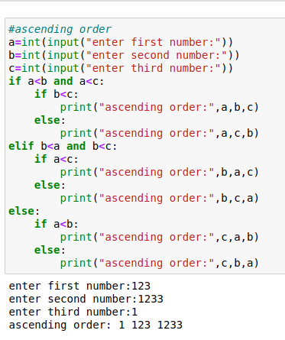
output:

Q2:
code

choice=input("enter a character:")
if choice>='0' and choice<='9':
print("you entered a digit")
elif choice>='A' and choice<='Z':
print("you entered an upper case letter")
elif choice>='a' and choice<='z':
print("you entered a lower case letter")
else:
print("you entered any other character")

Output:
